
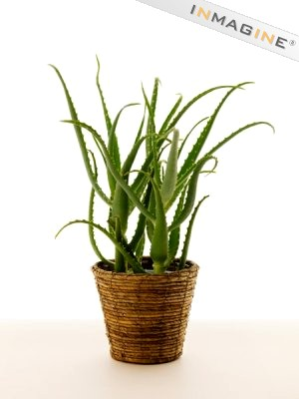



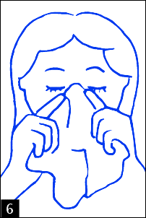
Prayer ideas-
Variations to break the routine
of classroom prayer

Heartfelt thanks to Keith Ballard for his support and for some of the materials in this document.
Prayer ideas- variations to break the routine class prayer

1 Pretzel Prayer-
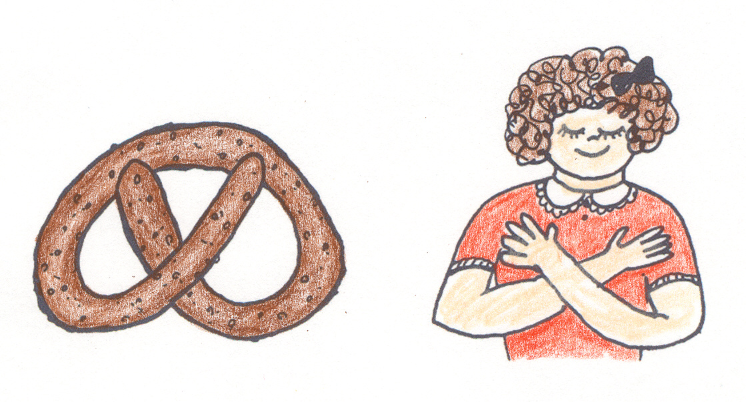
Link the pretzel shape to the shape of praying arms which is part of its origin in Eastern Europe. Talk about the food as the Lenten prayer food of poor people.

Possible method. Give out a single pretzel to each person and ask them to look at the shape and recognise the pattern of folded arms in prayer. Talk about the need to appreciate the food we have and value it. Invite the pupils to eat it slowly taste the salt and the bread make each crunch, tingle and taste a thank you for food. As they do that invite them to place their arms in the Pretzel shape. Meanwhile have someone read the following scripture passage and the italicised prayer:

Scripture Quote:
You are the salt of the earth. But if salt becomes tasteless what can make it salty again? It will be thrown away and trampled into the ground. You are the light of the world, let your light shine to all those around you.

Lord, thank you for the gift of food and for the strength it gives. Help me to appreciate that I have food and strength. Today, help me to be food for others, to give strength, support and kindness to others. Help me to feed their souls with my respect and kindness to them. Let me be bread and salt for their lives today. AMEN

2. Bubbles
Ask the class to sit at their desks and invite someone to go around blowing bubbles. Usually the group will try to reach and hold them as they sink towards the ground or blow them. Ask the bubble blower to come back to the front of class and stand by you. Ask them where the bubbles are now. They will say they have been burst. You can talk about the delicacy of bubbles, their beauty, their fragility. Point out that every day there will be moments of delicacy, of beauty that come and go very quickly. Like moments of praise, the look on the face of a friend, a piece of work that turns out well, a quiet joke with a friend. We need to appreciate these moments and not try to hold onto them because they are gifts from God, maybe just for you alone. Ask them to think of a good moment from the day before as you say this prayer.

Lord, you surround us with many good thing; nice clothes, good friends, and precious moments of peace and joy every day. Help us to notice these fragile moments and not ignore them. Remind us not to burst these bubbles of your spirit hidden in our lives and help us to celebrate the small blessings and bubbles of goodness you bring each day. We ask this through Christ Our Lord AMEN.

Finish with a set prayer and a sign of the cross.

3. Chocolate Stars
In many shops you can buy small packets of chocolate stars. Have one star ready for each member of the class. Begin the prayer time in the normal way. Invite them all to sit and talk to them about being a star. Who are the stars in their life? Move from the obvious celebrity stars of sport and film to the star people in their family. Can they recognise the stars at home? Then in this class there are stars; people who light up the lives of others. Can they quietly recognise the ones who bring light and hope into the lives of others. Invite the group to pray thankfully in silence for them. Remind them that, as Christians we are all called to shine, to be a light and a star for others. Read the scripture phrase.
“You are the light of the world, a city built on a hilltop cannot be hidden. No one light a lamp and puts it under tub. Instead they put it on a stand where it can shine out for many people. It is the same with you, you should let your light shine out for others to see and be encouraged.”
Invite the group to think of one thing that they can do today that will let their light shine out for others. If appropriate they can share that idea with the person next to them or a few can be invited to speak their idea to the whole class. Finally say the following prayer and afterwards invite the group to eat their stars or offer them to their neighbour..

Prayer Lord, make me a star today. Help me to be positive about my good qualities and share them generously with others. Help me to pick out the good things people do and give hope to those who are struggling. Keep me light-hearted and cheerful today and let your light shine inside me for all to see. AMEN
End with a set prayer and a sign of the cross.

4. Mirror
Bring in a reasonable sized mirror and after the normal introduction to the prayer ask someone to walk around the class holding it up so that people can see their faces in it for a few seconds. Some will look carefully, some will be embarrassed some will turn away. As this is going on ask the group how they feel they look? Do they like what they see? Would they want to change anything? Statistics tell us that less than 1 in 3 million people have perfect looks.
When we look at ourselves we need to look at God looks at us. He sees us as sons and daughters so we must have something of God inside each of us. Invite them to listen to the following scripture passage:
“Before I formed you in the womb, I knew you and I chose you to be with me forever. Before you left your mothers side I called to be a sign of my love”. (Jeremiah).

God knows us, loves as we are and invites us to love each other and ourselves in the same way. Let us Pray:
Lord thank you for loving each of us just as we are. Help us to recognise your face in the mirror when we look at ourselves and to respect your face hidden in family and friends. May we see your face today in teachers and pupils and not expect anyone to be perfect. We ask this through Christ our Lord AMEN.

Finish with a set prayer and a sign of the cross

5. Memorial book or Log book-
The form tutor can keep a record of special days that relate to the class. Birthdays, anniversaries of the death of family and friends can be included and recalled especially in November. There can be special feast days of name saints that will help to focus on class members with that name. Other events can be entered such as illnesses, successes, trips out, large school events and so on. The result is a kind of log book of the life of the class that can become a prayer focus. The book can be placed at a prayer focus with a candle and some of the entries can be read for a month or a term before. The teacher can help the class to reflect on how things have changed, settled or how people have adapted. The sacredness of these memories and many others can be emphasised by the teacher. Inside the book a number of scripture passages could be added such as. Jesus’ words before his ascension form Matthew’s Gospel or parts of Psalm 139. One of these extracts could be read after a brief pause to remember how things have changed with the class. If it is an anniversary of a death in a family a brief prayer could be said for that family. Otherwise the class could close with a prayer like this:

Lord, thank you for being with us through all of our story of life so far. Help us to grow through all these experiences. Be with us in this moment, in our future and in our past so that all our lives make sense and bring us closer to you who lives for ever and ever AMEN

End with a set prayer and a sign of the cross

6. Birthdays
Many young people like to emphasise their birthday but others are reluctant or shy in admitting them. One way around this is to have a brief birthday celebration once a month for all those who have a birthday in that month. That means the focus is shared and a whole group celebration is easier. It is an opportunity to celebrate individuals and recognise their gifts and speak positively about their good qualities. Such moments can reconcile people in the class through celebration. Bring in a cake and sing happy birthday to everyone involved. Then ask the birthday group to stand together and with the class gathered around them lead a prayer for them all. “Lord, bless (name them all) as they have become a year older. Guide each one of them as the mystery of their life unfolds. Protect them from harm, teach them your love and help us to recognise their goodness. AMEN. Then say an “Our Father as a whole group for them and then eat the cake.



7. Face the window-
Every classroom has a window out of which you can see a slice of the world. Occasionally you could ask the class to turn and face the window and pray in that direction. If you look at a map of the school (or ask the Geography department) you will find out that you are facing towards a direction that will take in a local town, further away rivers and hills and beyond that a number of other countries. If you are facing south you will almost certainly be looking towards a developing country. Find out the places along a line directly from your class room window, keep an eye on the news from those places and be ready to focus the group on those needs. Tie it together with the following kind of prayer.

“Lord we are in school, but we are preparing to go out to make a difference to the world. As we look into the world this morning there are people that are hurting, hungry and angry. May our prayer and work today prepare us to build a better world. May our learning today be for others, to make ourselves wise and not simply to pass exams. Make us ready to go out to build a better world AMEN.
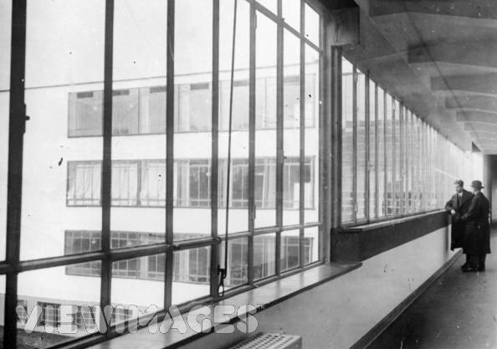
End with a set prayer and a sign of the cross

8. Stormy weather prayer-
If the class have been unsettled, back biting and angry recently bring in the weather forecast for the day. It will usually have some phrases like “bright intervals, overcast, deep depression, storms, sunny periods. Ask the group what the weather is like in the class? Collect a few words about the mood and emotions of the group; their inner weather. When they have expressed their unsettled feelings and the storminess of relationships read part of the calming of the storm to them from Mark 4.35. Then leave them a little silence to invite Jesus to come into their storms and say to their situation “be calm”. Then invite them to pray an Our Father and finish with a prayer like this: “ Lord, be with us in the storms and misunderstandings of our lives. Help us to awaken your presence when we are under pressure and not pass our anger on to others. Help us not to be afraid when storms happen but stay close to you and hang on until things calm don. AMEN

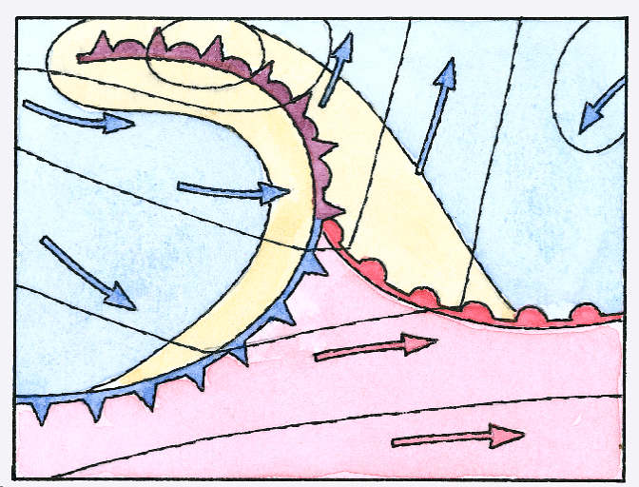

9. Going out of the classroom.-
Some times a significant incident occurs in the life of a class which causes surprise or shock. Perhaps a fight happened in the yard or a piece of work done by one of the form is put on prominent display. Maybe that has been an incident of bullying in a corridor or someone had to be taken to hospital after falling over. In these cases the form tutor may want to take the group to that place, remember what happened and invite the group to stand quietly to make sense of what has happened and then simply say an Our Father together before going back to registration.

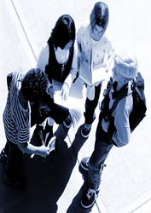

10 Calculator Prayer-
For those who like numbers using a calculator to lead into prayer can be helpful. Work out how many hours a person who lives until eighty will be alive (80x365x24) will give the total of 700,800 hours. A sixteen year old it is 140,160 hours. Which means 20% of their life is already over- if they reach 80 years. Alternatively do some sums on the fact that each person breathes 5.5 cubic metres of air each hour- how many cubic metres are there in the classroom and how much is the class using in just one hour? This mathematical reflection can lead to a meditation on the fact that we all rely on the same air, it is going in and out of all our lungs- we are connected in life. You may want to open the window! Occasionally using maths in this way brings pupils to a real sense of the preciousness and fragility of their lives and the need to care for each other and our environment. You could finish with a set prayer and then a prayer like this:

“Lord, you created us to live with you for 700,000 hours and then to be with you forever. Help us to use our time well and not waste it through worry or through laziness. Help us to get the most out of life and help other to do the same. You made us to belong to each other. Help us not to hurt each other by the choices we make but instead make this world safer and fairer for everyone”. AMEN



11 Blessings
The form tutor can become a key adult in the lives of their class and their one to one support can be vital. A form tutor can use the prayer time occasionally to go around the group and pray quietly in the form of a blessing by placing a hand gently on the pupil’s head and saying something like:
“May the Lord bless you and keep, may he make his face shine upon you and be gracious to you today and always. In the name of the Father and of the Son and of the Holy Spirit” AMEN.
Alternatively the form tutor may want to print that blessing out and give a copy to pairs in the class room who can give each other the blessing whilst some quiet music is playing.



12 Jacket uniform-
Most schools have a blazer as part of their uniform. An alternative morning prayer could be based around this garment, what it signifies and how they are looking after it. Here is one approach:

Invite the group to take their jackets off and put them on the desk in front of them. Look at the jacket starting with the badge. What does that mean? (Usually there is a symbol and a motto on the badge to focus upon). The brief discussion could raise a few points about the values they are asked to live by and how well they are doing that.

Next ask them to look at the state of the jacket. Does it still fit or are they growing out of it? Do they notice that they are growing? How are they growing up apart from physically? What state is their jacket in? Is it clean- whose is the cleanest? Whose is the shabbiest? The marks on the jacket record part of their story in school. Pen marks, food they have eaten and fun they have had. What does the jacket say about their time at school?

Finally have a look in the pockets and what the jacket is used to carry around. (Pens, mobile phones, money, paper, sweets). What other things do they carry into school- hopes and dreams, sadness friendships, fears? Undrneath that jacket how is the real you?

Next invite the group to fold the jacket over a few times and put their heads on it like a pillow and to listen to the following reflection:

Lord, we dress each day in our uniform
And come to school looking almost the same.
But you see the real person beneath the uniform.
You see the worries we carry into school
The skills and talents we hide beneath the surface.
You see the heart aches and fears we carry from home
And you know us through and through.

Stay with us today
And help us to put our trust in you
As we put this jacket on in a minute
Help us to realise how closely your presence
Is wrapped around us.
Holding us, knowing us, loving us
Every moment of this new day. AMEN

13 A Nose blowing prayer –
When colds and tiredness are obvious.
Give each person a tissue to play with.
Invite them to think about how they are feeling.
Ask those who are feeling sleepy and tired to wave their tissue in the air.
Congratulate them on getting into school even though not too lively.

Tell them that they are going to use the tissue to pray
And to wake themselves up.

Ask them to use the tissue to rub the sleep from their eyes as you say this prayer:
Lord, take the sleep from my eyes this morning
And help me to see more clearly
How lucky I am to be alive.

Now ask them to make a huge noise and blow their nose on the tissue and clear their heads. When the noise has settled say the following prayer:

Lord, clear my mind to start a new day
Take away any frustration and tiredness
So that I stay cheerful and friendly
Even under pressure.

Then say a set prayer in quiet for the intentions of the whole class.

Then say the following prayer as someone goes around collecting the tissues. Ask them to make the sign of the cross when they have put their tissue into the bin.
Lord, help us to let go of anything
That blocks our minds
Or closes our eyes
To doing the most loving thing today. AMEN

14. Secret soul friend-
As part of the ordinary morning prayer ask each person to write their name on a piece of paper then fold it up tightly and collect them in. Pass the papers out again so that each person gets another’s name. Invite each pupil to pray through the day or the week for the individual named on their piece of paper. Keep their identity secret by tearing up the paper immediately. Use the following prayer to start the personal prayer for one another

Lord we all have a name on a piece of paper
Which is torn into lots of pieces.
All of us feel broken up into pieces sometimes
No one has everything sorted all the time
So this morning I am going to pray for just one person
I ask you Lord to bless them today (or this week).
If they have their lives together
Help them to enjoy the day (week) ahead
And share their joy with others.
If things are rough for them at home or in school
Let them feel my prayers for them today (this week).
If their friendships are shaky
Let me be their secret friend in prayer.
Finally Lord, I ask you to be with them today (this week)
In every corridor and classroom
And in that secret place in their heart
Be the friend that is with them always
Until the end of time AMEN
The prayer above could also be written on a board so that all can say it together.

The prayer can end with a set prayer or a blessing. And the pieces of paper collected into the bin.



15. A Timetable Walk Through The Day
Ask the class to get out their organisers and find their timetable. Ask them to rate the day out of 10 based on the school day that lies ahead. Ask for a show of hands and work down from 10 out of 10 to just 1 out of 10. When the teacher has a feel for the mood of the class about the day ahead invite them to focus on the time table in front of them and follow the prayer below with their finger on the timetable or to close their eyes and use their imagination to follow the prayer.

It’s registration Lord, and I am waiting for the day to start.
Be with me in those first lessons as I get started.
Help me to keep focussed and stay relaxed
With the things and people I find difficult.
Be with me to keep me peaceful and ready to learn.

When I get to break time help me to relax
And to spend some good time with friends
And breathe in some fresh air and stretch my body
In relaxation and in play.

As the morning moves on Lord
Move with me into the next classes
Keep my ears open for the wisdom I will need.
Help me to hear the needs of those around me
And show me how to support those around me.

At lunch time be with me in what I eat
And those I share lunch with.
Help us to laugh about the day so far
And to welcome others into our group.

As afternoon class starts help me to get focussed
Sit with me when I feel bored
Talk to me in my heart if things get confusing
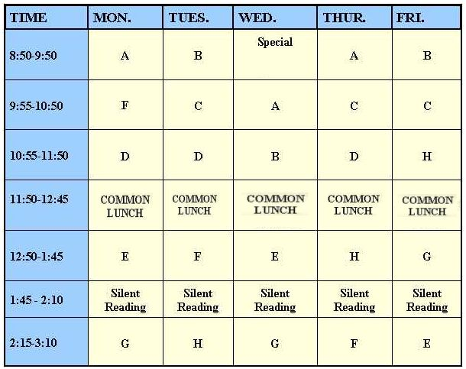
And bring me calmly to the final bell
At peace with you and with others
And ready to go home with you
To my family. AMEN

16. The bag Prayer
Most pupils bring a bag to school most days. In it they will have their books, PE kit, Lunch, pens and mobile phones. Ask the pupils to sit at their desks and put their bag in front of them and make the sign of the cross and then put their arms around the bag and use it as a pillow. Invite them to relax and close their eyes as they listen to this meditation:

Lord, we all bring things to school with us
Some of it is in bags like this
Some things we carry much deeper.
We carry books, P.E. kit homework and lunch boxes on our backs
But we also carry worries, anger at unfairness
Fears about ourselves and our families
And a heavy sadness over things that have gone wrong.

Today I will see lots of people wearing bags
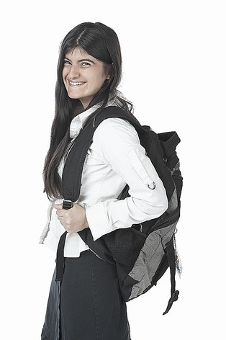
Some of them will be bright and cheerful colours
Some will look battered and covered with graffiti.
But people carry more than bags on their shoulders
Everyone carries burdens that lead them to worry
And we are not meant to carry these worries alone.
May the bags I see today remind me that I need help
To get through this day.
And that others need my help too
In a smile and in a kind word and through my understanding
I can ease the burden they may be carrying inside.

So be with me Lord to help carry my hidden baggage today.
So that I can help others.
You said “Come to me all you who are burdened and worried
And I will give you rest”
Today Lord I ask you to help me through this day
And show me how to help others too. AMEN

A set prayer can follow and a blessing from the teacher as they pick up their bags and leave the classroom.

17 Local News into Prayer

Each week ask 3 or 4 pupils to cut out a couple of newspaper headlines which have caught their eye and which they feel we ought to pray about. Ask each pupil to write a simple prayer for each situation. If this kind of prayer is used once each week a rota of pupils could be made up so that everyone has a turn.

On the morning they are to be used ask the pupils to come forward and pin their headline to the class prayer notice board and to give a little bit of background to the headline, e.g. what has happened, why they chose it. They should then be asked to read their prayer out to the class.*

Explain that many Christians believe that the community of Saints in heaven can also help us with their prayers. For this reason we can ask them and Mary, the mother of Jesus, to pray with us and for us as we say together the 'Hail Mary' (in prayer book).

*NB - it is common in Catholic communities for an individual to say a prayer and then finish with the words "Lord Hear Us". The rest of the group then respond "Lord graciously Hear Us'.



18. Prayer roll up
This short exercise needs a sheet of scripture phases that is appended at the end of this paper and also a long and thin slip of paper that can be rolled up very tightly. In addition each pupil will need a pen or pencil to write with. The aim is to connect the pupils personally with a piece of scripture that touches their heart or their present situation. With some discussion about the words from scripture on the sheet and perhaps the teacher sharing their choice of phrase and why it fits for them most pupils should get the idea. For example the teacher might say they feel tired and look worn out so they chose For you were made in my image from the list to remind themselves of the deeper beauty that people carry.
Once they have identified a reading they can write it on the piece of paper in as small a script as they can manage. Then, if appropriate, they can read those out to the class as part of the prayer. Ask the pupils to use the phrase as their own personal and secret prayer to God and repeat it many times during the day. When everyone has finished the following prayer can be said:

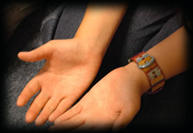
Lord your word is spoken into our hearts
Your word is hidden in each of us
Help us to listen to your word
And hear you whisper advice and wisdom
Into our lives today.
May this secret conversation with you
Help us to do what is right
And do the most loving thing
In every moment of this new day. AMEN

When the prayer has been said the teacher can talk about prayer slips like this and that some traditions like to sew them into clothing or wear them as hidden prayers in seams. (The Jews called them phylacteries and wore them on the arm or around the head). Invite the group to roll up their prayer slip after they have memorised the phrase and hide it on their clothing, in a deep pocket, or in the seam of a bag strap or even inside a pen as a sign of the hidden word of God that they carry with them each day. Later on that week check to see if they can remember the phrase. This can be repeated each term with a new phrase as their life and relationship with God develops.

19. Webs of friendship
You will need a ball of wool or strong thread. Ask the group to stand in a rough circle in the class room with their bags under desks. Give the ball of wool to a pupil and ask them to find the end and hold onto it then unravel a half metre so that it can be thrown to someone else. The new person catches the ball (hopefully!) and hold the thread and throws the ball to someone else opposite them in the circle. Bit by bit a network of connections is built up with the wool that get more and more complex. As far as possible involve everyone. If some are still left out invite them to hook a finger over the thread nearest to them. Then you are ready to point out a few things that can lead to prayer:

Teachers commentary on the network
We are all connected as part of this class group
The thread represents not just friendship but shared memories
It represents joys and tensions (feel the tension)
It represents connections that have become weak (relax the tension)
The network in front of us is also a picture of deeper connections
In the air we breathe, we share the same age group
We have the same spirit and an ability to care for one another.
This network also runs out behind us into our family
Into parents work and into the whole world
Which is a network that needs us to learn well
And prepare to become more connected as we get older.

Then having made a few points in a discussion the following reflection can be read:


Lord we are all connected
We all belong- even though we may be different from each other.
Because we belong together in school and family
There will be tensions- but that is part of being alive.
Help us to react well to tensions as a sign of life
And not give up on others who may need us more than they can say.
Help us to reach out to friends and make them welcome.
Remind us Lord that you are with us in all these relationships
Because you are at the heart of each person.
May the tensions and the tugging of hearts become a sign
Of your life giving love in our class, our friends and our family.
We make this prayer through the God who speaks to each of our hearts AMEN

To finish say a glory be to the Father and remind the group that breaking up the network does not end the deeper connections and responsibility we have for one another. Invite them to say the Lords Prayer and after a sign of the cross collect up the wool and ask them to sit down.

20. Seeds of new life
You will need a packet of seeds that you are sure will grow fairly successfully when planted in a pot in the classroom window. In addition you will need a plant out and some compost. Give a seed out to each person and ask them to hold it in their hand.
Reflection guidelines
- Reflect on the smallness of this little miracle of life that will unfold into something quite different in a few weeks time. You may want to refer to the parable of the mustard seed (Luke 13: 18) which starts small and leads to huge growth.
- You may want to remind the group that they too are still growing, still a mystery and it is not yet clear what they will become. They too are seeds caught up in a mystery of growing up together.
- Growing up true to yourself for young people means listening for what is deepest inside. Like the genetic code in the seed we have gifts, talents and a purpose that we need to find. Who am I, who do I belong to? What am I going to do?
- Most of us do not grow up in perfect ground. There are people and situations that make life difficult. Just as there are weeds and bad weather that can choke seeds. What situations stop us being ourselves? What angers and resentments get us twisted out of shape? How can we keep clear of the pressures that might spoil the deepest self?
- One of the things the seed has to do before the plant comes out is to change. It has to stop being a seed and become a plant and that happens in the dark when it is buried in the ground. We, as young people have to put away childish things and become young adults. We have to die to immaturity and grow to full strength, wisdom and kindness.
- In a moment you will be invited to plant your seed and as you do so I want you to think of something that you need to let go of in order to be more alive and more yourself. It could be something about your way of working, the way you get on with your family, the way you think about yourself or the way you treat friends.
- In the pause that follows think about what you want to let go of, what needs to change to lead to new and better life and then we will plant and water the seed as a class group. (Pause)
Read the following scripture passage a number f times as people plant their seed or read it once when they have all planted their seeds.

“Unless a grain of wheat falls into the earth and dies, it remains alone; but if it dies, it bears much fruit" (John 12:24)


Closing Prayer
Lord, we are all seeds growing to a deeper relationship with life
And the mystery of your presence.
Help us to listen for the call to life you give us each day
And not be distracted in growing strong and true
Into the unique person you call us to be. AMEN

End with a set prayer and a sign of the cross and then decide who will take care of the seeds and where they will be best placed.

Appendix1

The Words of God to me today would be:

You may not know me, but I know everything about you ~ Psalm 139:1
I know when you sit down and when you rise up ~ Psalm 139:2
Even the very hairs on your head are numbered ~ Matthew 10:29-31
For you were made in my image ~ Genesis 1:27
In me you live and move and have your being ~ Acts 17:28
I knew you even before you were born ~ Jeremiah 1:4-5
I chose you when I planned creation ~ Ephesians 1:11-12
You were not a mistake, for all your days are written in my book ~ Psalm 139:15-16
I determined the exact time of your birth and where you would live ~ Acts 17:26
You are amazingly and wonderfully made ~ Psalm 139:14
I knit you together in your mother's womb ~ Psalm 139:13
And brought you forth on the day you were born ~ Psalm 71:6
I am not distant and angry, but am the complete expression of love ~ 1 John 4:16
Simply because you are my child and I am your father ~ 1 John 3:1
My plan for your future has always been filled with hope ~ Jeremiah 29:11
Because I love you with an everlasting love ~ Jeremiah 31:3
I will never stop doing good to you ~ Jeremiah 32:40
For you are my treasured possession ~ Exodus 19:5
If you seek me with all your heart, you will find me ~ Deuteronomy 4:29
Delight in me and I will give you the desires of your heart ~ Psalm 37:4
For it is I who gave you those desires ~ Philippians 2:13
I am able to do more for you than you could possibly imagine ~ Ephesians 3:20
For I am your greatest encourager ~ 2 Thessalonians 2:16-17
I am also the Father who comforts you in all your troubles ~ 2 Corinthians 1:3-4
When you are broken-hearted, I am close to you ~ Psalm 34:18
As a shepherd carries a lamb, I have carried you close to my heart ~ Isaiah 40:11
One day I will wipe away every tear from your eyes ~ Revelation 21:3-4
And I'll take away all the pain you have suffered on this earth ~ Revelation 21:3-4
I am your Father, and I love you even as I love my son, Jesus ~ John 17:23
For in Jesus, my love for you is revealed ~ John 17:26
I am with you always, until the end of time Matthew 28:20
He came to demonstrate that I am for you, not against you ~ Romans 8:31
Jesus died so that you and I could be reconciled ~ 2 Corinthians 5:18-19
I gave up everything I loved that I might gain your love ~ Romans 8:31-32
If you receive the gift of my son Jesus, you receive me ~ 1 John 2:23
And nothing will ever separate you from my love again ~ Romans 8:38-39
Come home and I'll throw the biggest party heaven has ever seen ~ Luke 15:7
I have always been Father, and will always be Father ~ Ephesians 3:14-15
You are my beloved Son/Daughter in whom I a well pleased Luke 3:22
I am waiting for you ~ Luke 15:11-32

