Daily Prayer Patterns

For The Secondary School

Class Room

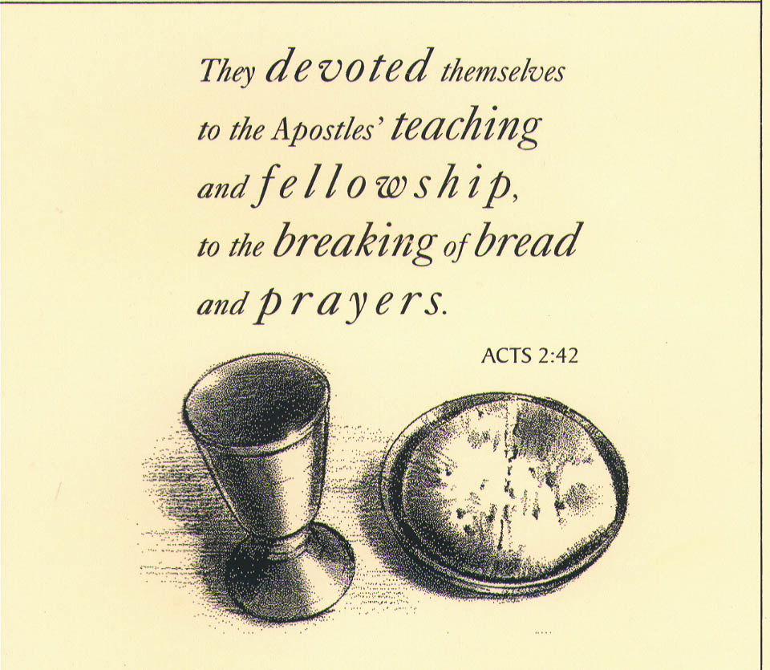

Routine Daily Prayer Patterns

The basic Pattern
The classroom is not an easy place to pray. It is a working space, often with focal points that are distracting and it is a place that can be noisy. In addition the social grouping of many young people makes it a volatile and peer pressured environment in which to motivate pupils to move beyond their normal modes of being together. Therefore a basic pattern and routine is needed to initiate prayer and link it effectively to young lives.

Initiating prayer Put prayer as the first thing on entering the classroom partly because it leads to less distraction and partly because it is a place of importance. There should be nothing on the desks. Bags should be under the tables and not on knees and not opened.

Posture: Pupils can stand if the prayer is very short otherwise they should sit. The teacher may want them to put their heads on the desk if a reflective prayer is used or to sit up straight and use their hands to make the sign of the cross which should initiate prayer on most occasions.

A focal point: The teacher should have some help in putting together a focal point very quickly. A colourful cloth in a draw, thrown over some books or an upturned bin can for a platform for a symbol. On that platform the teacher might ask a pupil to place a book, a candle, a cross or a plant or some other symbol that links to the prayer. Once the platform is there and one or two key symbols are visible the prayer can start.

Invitation to prayer. This should be a simple request to focus on the symbol and to invite the group to make a sign of the cross together.

Prayer; A variety of prayers can be read by pupils and short scripture verses can be added. It is here that the teacher will begin to build experience and skill in judging the mood; knowing when to talk gently and lead the group to silence, or to comment on something that happened in school in a prayerful way. There is scope for the teacher to pray aloud for his or her class in words such as these:

Lord I pray for each and every member of my form this morning
That they may have a good day today.
May they enjoy each others company without hurting each other.
May they learn a lot and enjoy supporting one another.
May their families be blessed in them
And may they keep safe and happy until they get home tonight. AMEN

A silent pause follows…………………

Ending
The group are invited to say an our Father or a hail Mary or a Glory be to the Father.
Then the teacher leads them in the sign of the cross and prayer is ended.

The components: The prayer section in the middle is open to infinite variation but it should involve a 1.spoken prayer, 2 symbols 3 silence and 4 some scripture, all framed by 5. a sign of the cross at either end. What follows are some variations and ideas for alternatives to this basic pattern

Pattern 1.Using The organiser

Open the organiser at this weeks pages.
Ask individuals to identify where they will need most help today.
Invite them to place their hand on the book at that place and close their eyes.

Then the teacher reads the following
Lord, in the week that lies ahead
There will be times when I will be challenged.
Be with me at those times
Keep me calm and controlled.
Remind me that you are with me in all that happens
And help me learn the hard lessons
As well as the easy ones.

Lastly identify what is the best spot of the week (probably Friday last period!). Invite the individuals to place their hand on the spot where they will be most happy and most themselves in school this week. (pause) Then say this prayer.

Lord, you gave us the gift of life
To be celebrated, shared and enjoyed.
Stay with us in the good times this week
And help us to have fun without hurting others.
Be the Lord of all of our lives this week.

This could be done for the week as a regular Monday exercise.



Pattern Two Using The Organiser
Have the group ready with their organiser and a pen- ask them to sit at their desks. Open up the organiser at today’s pages and ask them to listen to part of the end of Saint Matthew’s Gospel. (or the alternative phrase suggested below

The disciples went to Galilee
where the risen Jesus had arranged to meet them.
When they met Jesus they fell on their knees
and Jesus came to them and said
“all authority has been given to me.
So now I am sending you out
to make disciples of every person you meet.
Baptise them in the name of the Father the Son and The Holy Spirit.
Teach them the gospel way of living
and remember that I am with you every day,
I am with you always, until the end of all time”.

This is the Gospel of The Lord- All respond Thanks be to God

Then invite them to write “ I am with you always until the end of time”.in their organiser at the place where they will feel most under pressure during the week ahead.

Then say the following prayer.

Lord, you presence reaches deep into each persons life.
You know the story and the struggles
Of each person in this class.
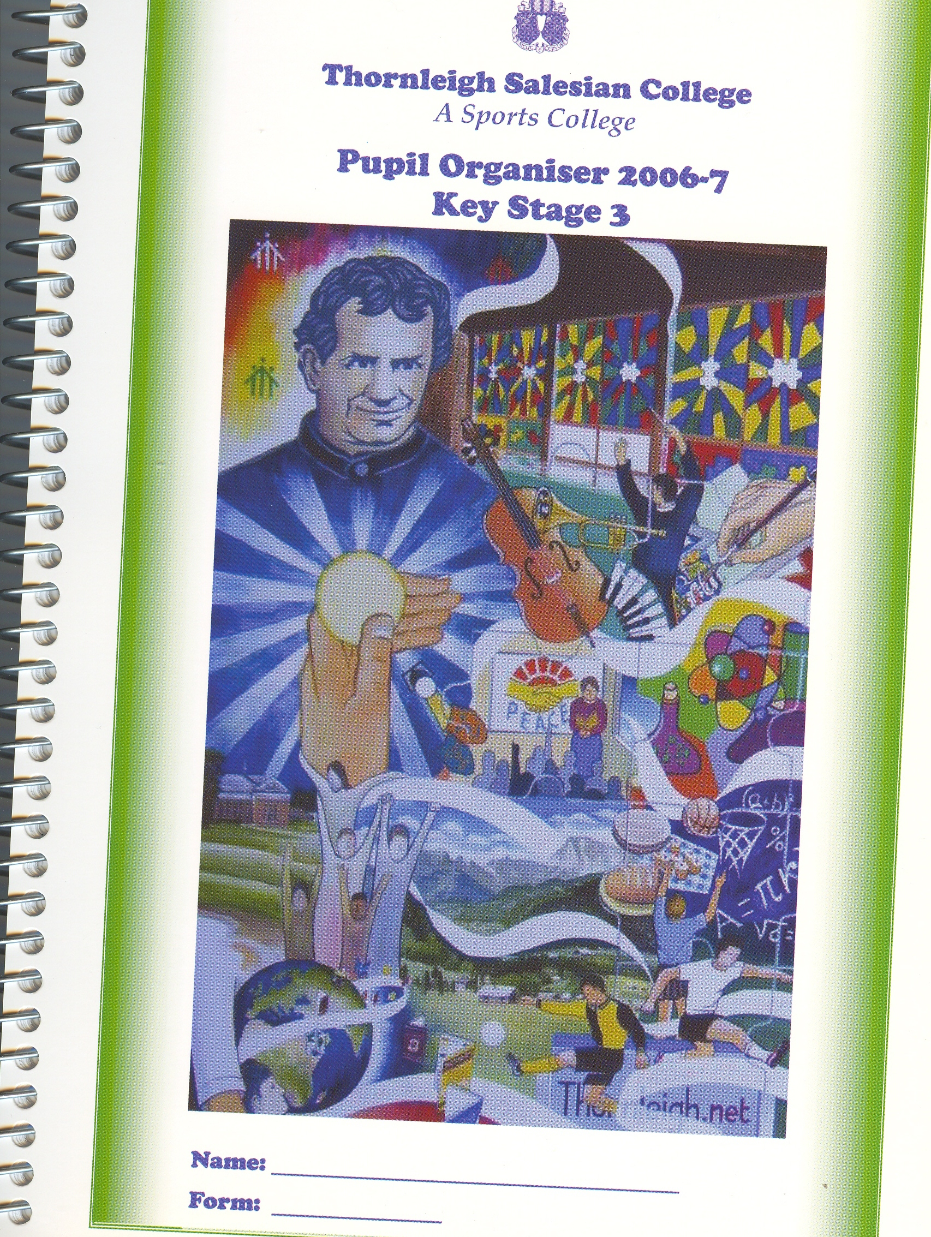
Stay with us during this week and help us
To what you would do.
Teach us to follow your Gospel
In our school and in our families
In our work and in our friendships. AMEN

Other scripture passages and written phrases
can be found in Appendix 1

Pattern 3- using a candle

Prayer focus- light a candle and place a cross- upend the bin with a cloth over it to make it more visible. Move it from desk to desk and get the pupils to set it up- invite the others to stand and turn towards it.

Watch the flame- invite them to focus on the flame
If possible turn out the classroom lights
Talk about the flame needing air to breathe
Talk about us burning air
Invite them to breathe slowly and deeply- pause-
Invite someone to do a reading or a say a set prayer
At the end of that set prayer invite someone to hold and raise the candle so everyone can see it.
Say this prayer or ask someone else to say the prayer

Lord of light
Stay with us during this day
Guide us to say and do the right things
And let the light of your goodness
Shine through everyone in school today.
Remind us of the light of your presence inside us
Especially when we feel sad or scared today. AMEN

Make the sign of the cross together and invite the person holding the candle to blow it out.

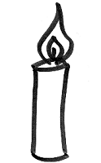

Pattern4. –Using hands
Invite pupils to sit and clear the desk.
Make the sign of the cross
Ask them to look at their hands and notice how they are this morning ( hot, cold, clean, dirty, relaxed tense.
Then use a script like this:
What things do these hands carry this morning?
Memories of home- of getting up and getting to school
Tensions from the family
Memories of holding and helping others
Memories of anger and wanting to fight
Maybe these hands show worry about the day that lies ahead
Maybe eagerness to enjoy special moments today.
These hands are called to express love and tenderness
To be raised in defence of others
To be used in study and in sharing food.
These hands will be part of your life today
To do good or to do harm.

Then do one of the following:
Invite them to screw their fists up tightly and hold them tight
Slowly release the tension and let their hands unfold. Do that three times.

Then say or ask someone else to say the following prayer:

Lord, keep me free from too much tension today
Keep me relaxed and gentle in all that I do.
May I never raise my fists in anger
But offer a helping hand to those around me
Help me to grow in skill through these hands
May they help me to build a better world
And protect and defend those who need my help.

To finish invite the group to say a set prayer and then to gently blow on their hands as you say. “Lord breathe peace into our hands and into our hearts today. In the name of the Father and of the Son and of The Holy Spirit AMEN….

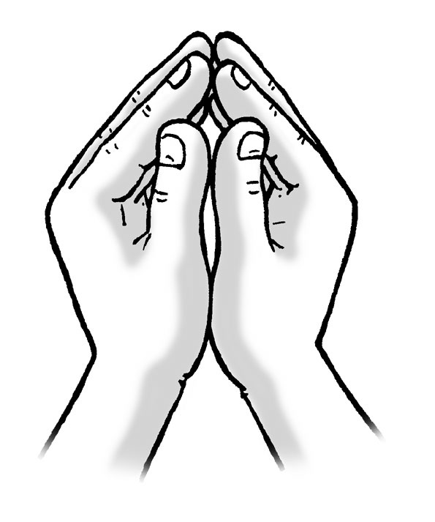

Pattern Five Using Hands
Invite the group to sit and make the sign of the cross
Place one hand flat on the desk and stretch it so that you can see the lines.
Ask them to look for the big m shape in the palm of their hand
Invite them to trace their finger along those lines slowly and repeat that action
For each line of the following prayer.

“Into your hands I commit this day
I commit into your hands Lord each lesson on my timetable
I place in your hands my friends and family.
I put my hopes and dreams into your hands
And each and every worry that is in my heart.
Hold my life in the palm of your hand
And keep me safe through this day.”

Extend this by adding intentions- e.g. :

“Into your hands I commit the health of xxxxx
Into your hands I commit the results of our exams
Into your hands we commit Tracy’s grandma
Into your hands we commit the football team that will play tonight.

Finally ask the group to be still for a moment and think of their own needs
Then ask them to breathe those needs into their outstretched hands
Then bring both hands together and finish with a set prayer and a sign of the cross.

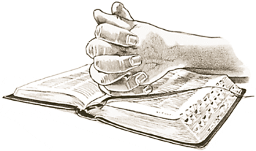

Pattern Six Morning Litanies

Once the focus is established ask the group to be in silence and let their mind run over the day ahead. They can put their heads on the desk and just let these prayers wash over them and say the reply quietly to themselves.

For those who have not done their homework today-
For those who are tired and have not slept well
Response by all: Lord help them

For those who have problems at home.
For those in this class who have fallen out with each other
For those in this school who are frightened today
For those who get bored easily
For those who will lose their temper today

For pupils and staff who have happiness to share
For the ones who can make peace when others have fallen out
For those who make us laugh and relax
Response by all: Lord we thank you
For those of us who are good listeners
For the ones who always encourage others
For a new day to do new things
For a fresh start and a chance to change
For adults in our lives that care about us
For the challenge of learning new things
For the dreams we have for success.

Now, lets pause and remember the mystery of our lives and the unique day that lies ahead.

(pause)

Then invite the group to say a set prayer and finish with the prayer below.

Lord, as we begin this day
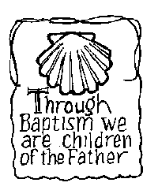
Be with us in everything that happens
Be at the start and ending of all our lessons
And help us to learn from each other about who we are
Even as we learn about the subjects we study.
Be a friend on today’s journey
And bring me safely to the end of today
Deeper in wisdom and closer to other people AMEN

Make the sign of the cross and blow out the candle

Pattern Seven using the pupils own prayer book

Invite the pupils to write their own prayers and decorate them in colour on A4 sheets of paper. They can then be inserted into a display type book and used as the class prayer book. Each time it is used the person who wrote the prayer can be invited to read it to the class. The prayer book can be kept at a focal point and carried in a formal way to whoever is going to read from it. You might ask the chaplain to come into class and bless the book for you on behalf of the school In addition to the pupils own prayers they may also like to add favourite prayers that they have found and add them to the book too. In that case they should sign the prayer at the bottom of the page as the one who added it to the class collection.

Writing the prayers.
The prayers, if they are to be used widely will need to cover a range of different uses. Some prayers will be used often and others on special occasions. You may wish to select a few pupils to write a prayer for the same occasion where they are common events. These are the subjects you will need to have prayers for:

A Morning offering- Asking God to take the day, be with them in all that happens an keep them safe.

A Thanks-giving prayer. Saying thank you to God for a widerange of things and leaving space and a silence for special and personal thanksgiving for individuals to pray about in their own hearts.

A prayer for forgiveness- Telling God that the group is sorry for the thoughtless and hurtful things they have done, maybe for laziness lack of care for each other. Finish the prayer with a promise to do better in the future with God’s help.

A prayer for a bereavement- This is a prayer for those who are sad and have lost family and need to be comforted. It should involve asking God to be with the bereaved person and a promise to pray for them as well as a mention of resurrection and heaven.

A prayer for a birthday- this is a blessing prayer for the person who is a year older. It should recognise the opportunity to thank the person and to promise prayers for a happy day and continued growth in health and wisdom.

Prayers of intercession are 5 prayers asking for the needs of others. They begin with a phrase like We pray for (state the intention) then a pause follows finally another sentence sums up the prayer asking God to give us strength and support those in need. The prayer ends with a response “Lord hear us” responded to by all saying “Lord graciously hear us.”

Using The Prayer Book
The prayer focus can be a candle and the book on a table visible to the group. A class member lights the candle. The sign of the cross is made with the teacher. Another class member comes forward and picks up the book and reads a morning offering. All say Amen and then there is a pause. The teacher may then add a scripture reading or tell a story based on scripture. Then a third person comes forward and reads one or two intercessions. Others may be added if people have intentions. The teacher invites everyone to pray a set prayer. The sign of the cross is made and the candle blown out.

Appendix One
Reading One
It was Sunday and doors were closed in fear
When Jesus came and stood among his disciples

Jesus gave them peace to calm their fears
And he showed them his wounded hands and feet.

Peace be with you Jesus said again
And called them into the way of risen life

Jesus breathed on them and the Spirit moved their hearts
A Spirit of peace and new beginnings

Happy are those who have not seen
And yet see clearly with the eyes of faith.

Glory be to The Father……….

Write : peace be with you in the organiser
Then say an Our Father and summary prayer
Then a blessing prayer

Reading Two
Blessed are those who do not walk in bitterness
And turn their steps away from anger and pessimism.

Blessed are those who search out God’s presence
And uncover the law of love day and night.

They are like trees planted beside flowing waters
They will never become hard hearted or wither in spirit.

They will not be blown about by misfortune
But stay faithfully rooted in God’s goodness

Whatever they do will be drawn into God’s wise plan
And the fruit of their lives will last forever.

Glory be to the Father…….

Write : be drawn into God’s plan
Then say an Our Father and summary prayer
Then a blessing prayer

Reading Three
I will become the shepherd of my sheep says the Lord
And I will seek out the lost and the hidden

I will rescue them from unhealthy places
And bring them home to their own land

When they are storm scattered
I will gather them together in safety

I will collect the strays and heal the hurt
I will build up the weak and guide the strong

For you are my own flock
And I am your shepherd God.

Glory be to the Father……..

Write : Be my shepherd and guide today
Then say an Our Father and summary prayer
Then a blessing prayer

Reading Four

The Lord says: Do not be afraid, you are my people
We belong together, I have named each one of you.

When you are out of your depth I am still with you
When the waters are rough you will not sink

Because I am God, you cannot sink beyond my care
With me there are no dead ends on the journey to life

So do not be afraid, I am with you each day
And I will gather all that has been scattered.

I will bring you home to the heart of God
Because I made you to be with me forever.

Glory be to the Father

Write : Do not be afraid I am with you
Then say an Our Father and summary prayer
Then a blessing prayer

Reading Five- Jeremiah

The people that fled into the desert
Have found God’s friendship

Looking for a place to escape to
They discovered God searching for them.

And so they began to love their God again
And built their lives around God’s presence

They were met by God with an everlasting love
An unchanging affection for God’s faithful

In that love they rebuilt their lives together
And instead of a grumbling silence they began to sing

Glory be to the Father ……..

Write : My love for you is everlasting
Then say an Our Father and summary prayer
Then a blessing prayer

Prayer Six Wisdom Chapter 9

Lord, all wisdom comes from you
A wisdom that is beyond understanding

Send that wisdom into our lives
To help us and work with us today

May wisdom guide our choices
And protect us from folly in our plans

None of us can understand your plans Lord
We need to trust your wisdom

It is only in God that we can learn wisdom
Through the spirit that has been sent into our lives

Glory be to The Father……….

Write : Lord, work with us today
Then say an Our Father and summary prayer
Then a blessing prayer

Prayer Seven Luke’s Gospel 13.18

What is the kingdom like to what can I compare it?
It is like a small mustard seed thrown onto the ground
That becomes a tree in which the birds can shelter

The kingdom of God is like a small pinch of yeast
Transforming plain flour into risen bread
Feeding deep and hidden hungers

Don’t always take the easy way out of problems
Instead, enter by the narrow door
Stay focussed on the hidden life of the kingdom.

Do not let yourselves be cut off from God
Or be locked out of the celebration of the kingdom
Do not let your love of God become a thing of the past.

Glory be ……..

Write : Lord, help me to do the right thing today
Then say an Our Father and summary prayer
Then a blessing prayer

Prayer Eight Matthew 7.13
Don’t always take the easy way out
There are no short cuts to friendship with God

Try to enter by the narrow way of self denial
And by the hard road of committed trust in God

Be slow to trust others as guides for the journey
Judge by what they are and not by what they say.

It is not those who have the right words that matter
But the ones who do the Father’s will.

Those who listen and follow the Father’s will
Build their lives on an eternal foundation

Glory be to The Father……….

Write : Build my friendship with you today Lord.
Then say an Our Father and summary prayer
Then a blessing prayer

