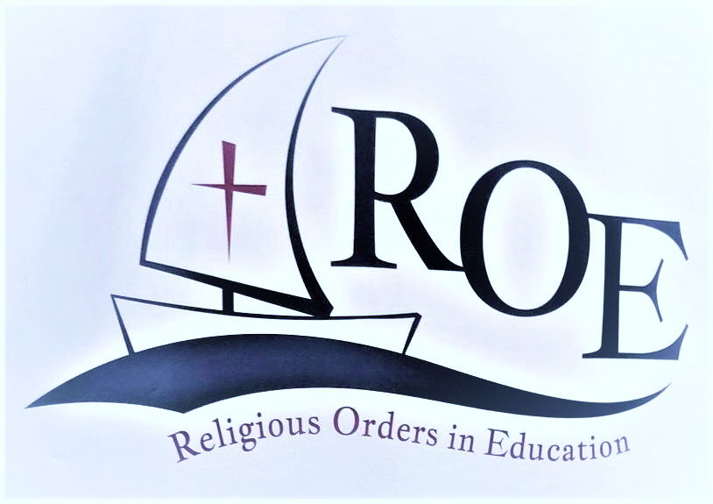
HEAD
TEACHERS
QUOTES

It’s important that everyone in our school community knows that they can be a spiritual leader.

Discovering that being Head also involved being a spiritual leader has been transformational for my faith and I am now passionate about sharing it

In these days of fewer religious vocations, it is even more necessary for us laity to help in the handing on of the Charism. Now it is the laity that will drive the religious Charisms.

We need to encourage people (even Catholics) to ask questions. We need to find ways and time to deepen our own and others’ faith in school.

To me charism feels like coming home to one another and to oneself, a sense of being called to be present to others.

Let’s not forget that teaching is a church ministry and not just another job.

These were drawn from three symposia through the last academic year

